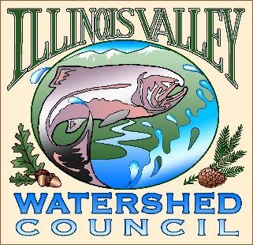 | Illinois Valley Watershed Council  331 E Cottage Park Suite 1B - P.O. Box 352  Cave Junction, OR 97523  Phone: 541-592-3731

Monthly Council Meeting Agenda

May 4, 2023 IVWC Office/ZOOM

- 5:00 PM: Call to Order
- 5:05 PM: Acceptance of Minutes
- 5:10 PM: Acceptance of Financial Reports
- 5:30 PM: Old Business

  - Strategic planning update
  - Josephine County Update

- 5:50 PM: New Business

  - Meeting Date Change June - Action
  - Forest Service Slater Fire Environmental Assessment Discussion

- 6:10 PM: Council Updates & Staff Reports
  - Kevin report
  - Arlyse report

- 6:20 PM: Public Comments (Relating to this agenda or IVWC Operations)

- 6:30 PM: Adjournment

