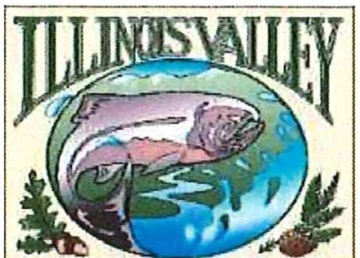
WATERSHED
� @ l!JJ � <r;: O lb
Illinois Valley Watershed Council
331 E Cottage Park Suite 1 - P.O. Box 352
Cave Junction, OR 97523 Phone: 541-592-3731

Monthly Watershed Council Meeting Notice and Agenda
Thursday, June 11, 2026
331 E Cottage Park Drive Suite 1 or Join the Zoom Meeting
Topic: Illinois Valley Watershed Council Monthly Meeting Time: June 11, 2026 6:00 PM Pacific Time
IVWC is inviting you to a scheduled Zoom meeting.
Join Zoom Meeting https://us06web.zoom.us/j/86960686555?pwd=l3d3cubho6V6N6xpdJ9ANOOfhQTcAE.1 Meeting ID: 869 6068 6555
Passcode: SaveFish One tap mobile
+17193594580,,86960686555#,,,,*94761306# us
+12532050468,,86960686555#,,,,*94761306# us
Join instructions https://us06web.zoom.us/meetings/86960686555/invitations?signature=zSwk2q TPg3kWnb4qFRBh5tOZ4-yQc4XcJTAGCdQiXs

- 6:00 PM: Call to Order
- 6:01 PM: Acceptance of Minutes
Ill. 6:05 PM: Acceptance of Financial Reports
- 6:10 PM: Committee Reports
  - Policy {Electronic Voting)
  - Recruitment & Development (BoD recruitment update)

- 6:25 PM: Old Business
  - Movie Night - Friday, June 26th
  - Hathkapasuta - Saturday, June 20th

- 6:40 PM: New Business
  - Possible Engagement Opportunities

- 6:55 PM: Council Updates & Staff Reports
  - Kevin's report
  - Board Action Items/Homework {Read your packets before the meeting, plz!

- 7:10 PM Partnering Agency Reports

- 7:15 PM: Public Comments (Relating to this agenda or IVWC Operations)

- 7:20 PM: Adjournment

1

