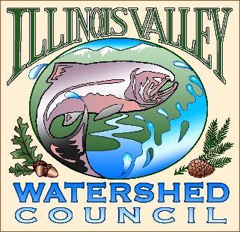 | Illinois Valley Watershed Council  331 E Cottage Park Suite 1B - P.O. Box 352  Cave Junction, OR 97523  Phone: 541-592-3731

Bi-Monthly Council Meeting Agenda

November 18, 2021 IVWC Office/ZOOM

- 6:00 PM: Call to Order
- 6:05 PM: Acceptance of Minutes

- 6:15 PM: Acceptance of Financial Reports

- 6:30 PM: Old Business
  - Storage Update
  - Draft Memorandum of Understanding
  - Further Organizational Restructuring Discussion
  - Water Quality Goals & Objectives action item

- 6:45 PM: New Business
  - TBD- Possible presentation on potential clear-cuts
  - Commissioner Fowler??

- 7:15 PM: Council Updates & Staff Reports
  - Kevin report
  - Arlyse report

- 7:30 PM: Public Comments (Relating to this agenda or IVWC Operations)

- 7:45 PM: Adjournment

