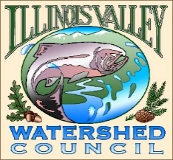 | Illinois Valley Watershed Council  331 E Cottage Park Suite 1B - P.O. Box 352  Cave Junction, OR 97523  Phone: 541-592-3731

Monthly Watershed Council Meeting Agenda
Thursday, October 10, 2024

- 5:00 PM: Call to Order
- 5:02 PM: Acceptance of Minutes
- 5:05 PM: Acceptance of Financial Reports
- Committee Reports
  - Draft Contracted Cervices policy. *Discussion/Action*
  - All-Council Community Engagement Session postponed to November 9 10am-12 noon.

- 5:25 PM: Old Business
  - Page Creek Planting

- 5:50 PM: New Business
  - Clear Creek Water Lab *discussion only*
  - Plant Sale Idea

- 6:15 PM: Council Updates & Staff Reports
  - Kevin report
  - Arlyse report
  - Board Action Items/Homework

- 6:30 PM Partnering Agency Reports
  - Illinois Valley SWCD
  - Others

- 6:45 PM: Public Comments (Relating to this agenda or IVWC Operations)

- 7:00 PM: Adjournment

