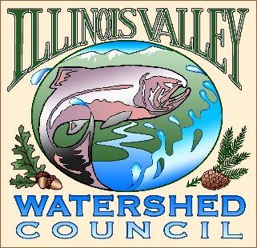 | Illinois Valley Watershed Council  331 E Cottage Park Suite 1B - P.O. Box 352  Cave Junction, OR 97523  Phone: 541-592-3731

Monthly Council Meeting Agenda

February 2, 2022 IVWC Office/ZOOM

- 6:00 PM: Call to Order
- 6:05 PM: Acceptance of Minutes

- 6:10 PM: Acceptance of December 2022 Financial Report

- 6:15 PM: Old Business

  - Strategic planning update (Kevin)
  - Budget Committee Report and COLA Recommendation (Katrina)
  - Water Quality Monitoring (Kevin/John)
  - Pomeroy Dam Removal update (Kevin)

- 6:40 PM: New Business
  - Don Young re-appointment (Action)
  - Bank Signers- Umpqua Bank (Arlyse)
  - Schedule next Budget Committee Meeting (2/13/2023?!?)
  - Appoint liaison to IVSWCD for meeting attendance

- 6:50 PM: Council Updates & Staff Reports
  - Kevin report
  - Arlyse report

- 6:55 PM: Public Comments (Relating to this agenda or IVWC Operations)

- 7:00 PM: Adjournment

