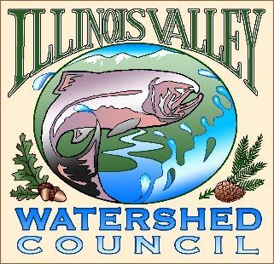 | Illinois Valley Watershed Council  331 E Cottage Park Suite 1B - P.O. Box 352  Cave Junction, OR 97523  Phone: 541-592-3731

Monthly Council Meeting Agenda

October 12, 2023

- 5:00 PM: Call to Order
- 5:20 PM: Acceptance of Minutes
- 5:25 PM: Acceptance of Financial Reports
- 5:35 PM: Old Business
  - Strategic Planning Update

- 5:50 PM: New Business
  - Confirm Crook Creek Site Visit date
  - Recent resignations/state of the union
  - Open season November
  - Budget meeting- Dec? Revisit committee composition

- 6:10 PM: Council Updates & Staff Reports
  - Kevin report
  - Arlyse report (written only)

- 6:20 PM Partnering Agency Reports
  - Illinois Valley SWCD
  - Others

- 6:25 PM: Public Comments (Relating to this agenda or IVWC Operations)

- 6:30 PM: Adjournment

