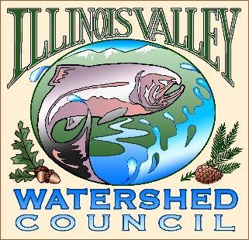 | Illinois Valley Watershed Council  331 E Cottage Park Suite 1B - P.O. Box 352  Cave Junction, OR 97523  Phone: 541-592-3731

Monthly Council Meeting Agenda

August 3, 2023 IVWC Office/ZOOM

- 5:00 PM: Call to Order
- 5:20 PM: Acceptance of Minutes
- 5:25 PM: Acceptance of Financial Reports
- 5:35 PM: Old Business

  - Josephine County BoCC Update
  - Crooks Creek Project Update
  - OWEB Passive Water Quality Monitoring Update

- 5:50 PM: New Business
  - OWEB 23-25 Capacity Award/2021-2023 wrap up (presentation)
  - East Fork Illinois- Mendoza Project
  - Strategic Planning
  - Forest Service partnership Update

- 6:10 PM: Council Updates & Staff Reports
  - Kevin report (Oral only)
  - Arlyse report

- 6:20 PM Partnering Agency Reports

- 6:25 PM: Public Comments (Relating to this agenda or IVWC Operations)

- 6:30 PM: Adjournment

