Co
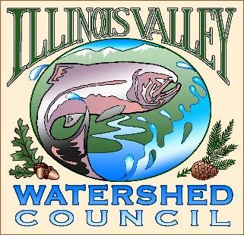 | Illinois Valley Watershed Council  331 E Cottage Park Suite 1B - P.O. Box 352  Cave Junction, OR 97523  Phone: 541-592-3731

Monthly Council Meeting Agenda

May 26, 2022 IVWC Office/ZOOM

- 6:00 PM: Call to Order
- 6:05 PM: Acceptance of Minutes

- 6:10 PM: Acceptance of Financial Reports

- 6:15 PM: Old Business
  - Strategic planning update
  - Annual Assessment

- 6:30 PM: New Business
  - Personnel Policy Manual/Employee Handbook (WC does not have one)

- 6:40 PM: Council Updates & Staff Reports
  - Kevin report
  - Arlyse report

- 6:50 PM: Public Comments (Relating to this agenda or IVWC Operations)

- 7:00 PM: Adjournment

