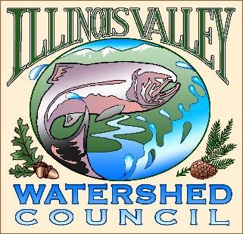 | Illinois Valley Watershed Council  331 E Cottage Park Suite 1B - P.O. Box 352  Cave Junction, OR 97523  Phone: 541-592-3731

Monthly Council Meeting Agenda

March 2, 2023 IVWC Office/ZOOM

- 6:00 PM: Call to Order
- 6:05 PM: Acceptance of Minutes
- 6:10 PM: Acceptance of Financial Reports
- 6:15 PM Guest speaker- Eric Larsen Sewage Treatment Plant Operator, City of Cave Junction
- 6:30 PM: Old Business

  - Strategic planning update
  - Signers- need every signer’s information sheet before next steps.
  - Budget Committee Update 23-25 Biennium Budget-Action
  - WQM update

- 6:50 PM: New Business

  - Network of Networks Event- Need representation.
  - Updating Watershed Coordinator Job Description/Performance Standards
  - Watershed Coordinator transition planning
  - Coming Attraction: Acronym Legend

- 7:10 PM: Council Updates & Staff Reports
  - Kevin report
  - Arlyse report

- 7:20 PM: Public Comments (Relating to this agenda or IVWC Operations)

- 7:30 PM: Adjournment

