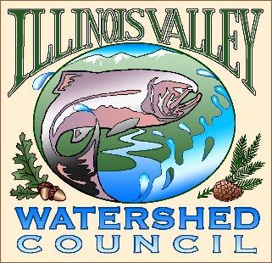 | Illinois Valley Watershed Council  331 E Cottage Park Suite 1B - P.O. Box 352  Cave Junction, OR 97523  Phone: 541-592-3731

Monthly Council Meeting Agenda

April 6, 2023 IVWC Office/ZOOM

- 5:00 PM: Call to Order
- 5:05 PM: Acceptance of Minutes
- 5:10 PM: Acceptance of Financial Reports
- 5:30 PM: Old Business

  - Strategic planning update

- 5:50 PM: New Business

  - Roger Brandt- Old Stage Park
  - Owl III proposal-action
  - Ratification of votes taken outside meeting time
  - Policy requirements for Capacity Grant-ACTION

- 6:10 PM: Council Updates & Staff Reports
  - Kevin report
  - Arlyse report

- 6:20 PM: Public Comments (Relating to this agenda or IVWC Operations)

- 6:30 PM: Adjournment

