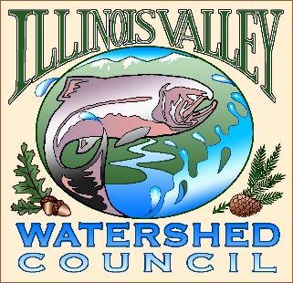 | Illinois Valley Watershed Council  331 E Cottage Park Suite 1B - P.O. Box 352  Cave Junction, OR 97523  Phone: 541-592-3731

Bi-Monthly Council Meeting Agenda

July 22, 2021 IVWC Office/ZOOM

- 6:00 PM: Call to Order
- 6:05 PM: Acceptance of Minutes

- 6:15 PM: Acceptance of Financial Reports

- 6:30 PM: Old Business
  - Capacity Grant 21-23 Approval- review
  - Water subcommittee

- 6:45 PM: New Business
  - SWCD Community Organizer Introduction
  - Farmer’s Market- Action Item

- 7:15 PM: Council Updates & Staff Reports
  - Kevin report
  - Arlyse report

- 7:30 PM: Public Comments (Relating to this agenda or IVWC Operations)

- 7:45 PM: Adjournment

